# Macintosh HD:Users:z018620:Dev:Helps:Icons:ValiTag:ValiTagAppIcon-01.pngValiTag – User Guide

Version 1.2

12/23/2016

## Introduction

ValiTag is a standalone application for validating the RFID EPC tag encodings used in Target’s supply chain. It works with proprietarily encoded EPC GIDs that contain Target’s DPCI number, as well as national brand merchandize that uses an EPC encoded, serialized GTIN, or SGTIN. The app scans the RFID EPC tag, and simultaneously scans the printed bar code and makes sure they match. If so, a green check is displayed. If not, a red circle with a line through it is displayed.

## Requirements

An iOS device (iPod, iPhone, iPad) running iOS 8.x or higher

A supported RFID reader – one of:

* Zebra RFD8500
* Intertek uGrokit GR-1.5-915

Use MyAccess to join: App-ValiTag-User

The ValiTag application from the Target Application Zone (TAZ)

## Setup

Launch TAZ and download and install ValiTag

Before launching ValiTag, you must connect a reader

* For the uGrokit reader, plug it into the headphone jack
* For the Zebra reader, use iOS Settings to connect via Bluetooth

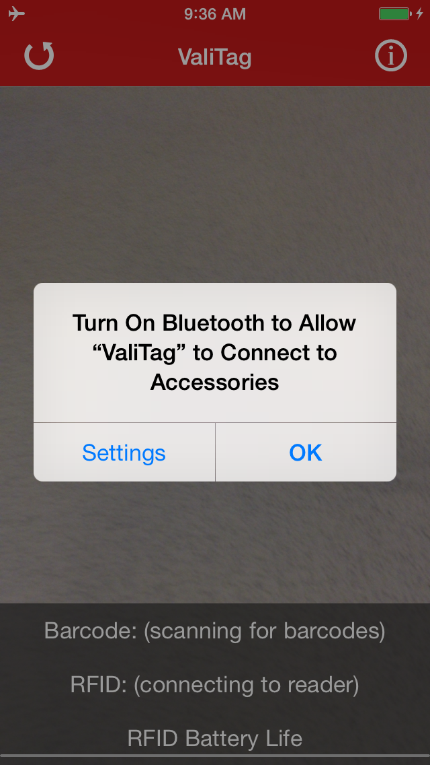Note: If you are NOT using a Bluetooth reader, you can disregard the Bluetooth warning dialog presented at start up (if your Bluetooth is disabled). Just click OK.

If you are using a Bluetooth reader, click on the settings button and configure Bluetooth as outlined in the next section

## Bluetooth Setup

### On the RFID reader

Turn on the Bluetooth reader

Press and hold the Bluetooth paring setup button until the blue light is flashing slowly (if you just turned it on, or installed a new battery, it may already be flashing)

### On the iOS device

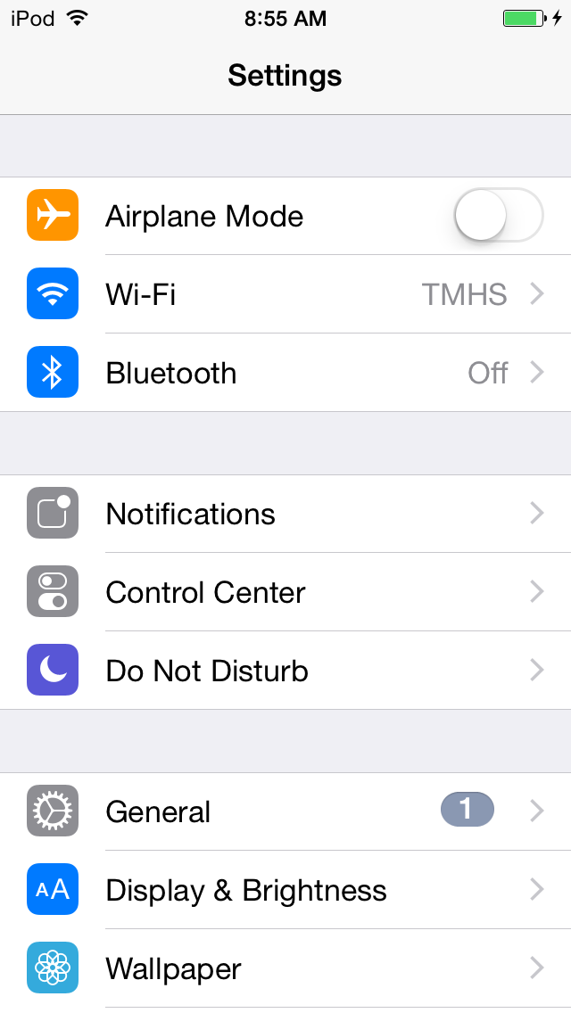

Open Settings and click on Bluetooth:

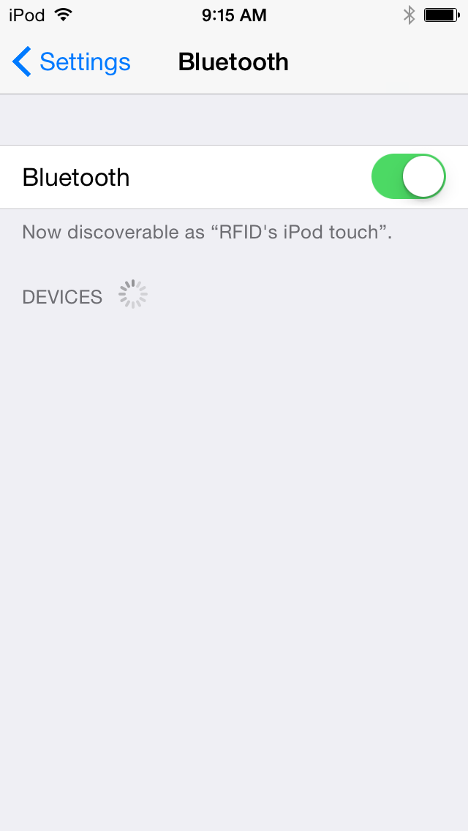Make sure Bluetooth is on:

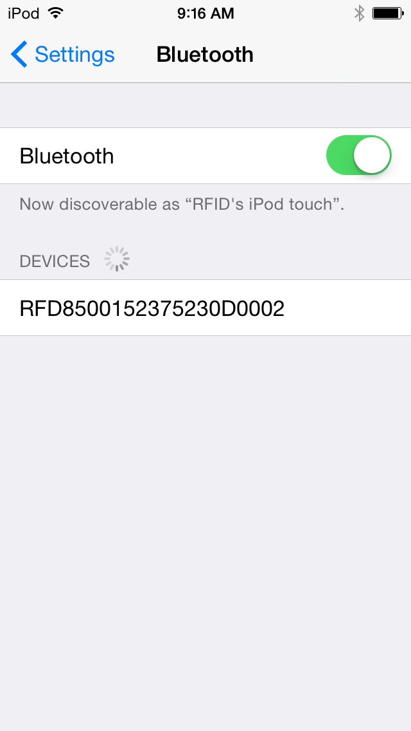

With the blue Bluetooth pairing light flashing on the RFID handheld, select the RFID device in the devices list:

### On the RFID reader

The Bluetooth pairing light will now begin flashing more quickly. Pull the trigger on the handheld to confirm pairing (this is a security feature – you must have physical possession of both devices to successfully pair them).

### Macintosh HD:Users:z018620:Pictures:iPhoto Library.photolibrary:Masters:2015:09:21:20150921-091654:IMG_0014.PNGOn the iOS device

The RFID device should now show as connected. If not, repeat the steps in this section until a successful connection is established:

You should now be paired, and can open the application.

## Launch ValiTag

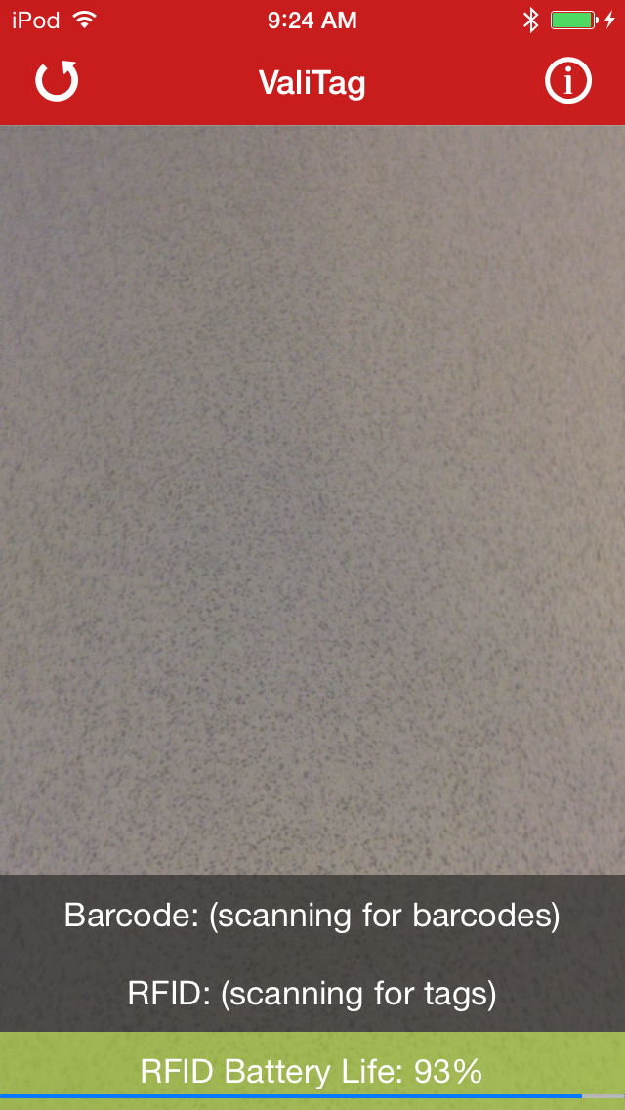If the reader is properly connected, you should see the RFID Battery Life displayed (see troubleshooting if not), and the RFID label should say “Scanning for tags” (see troubleshooting if not):

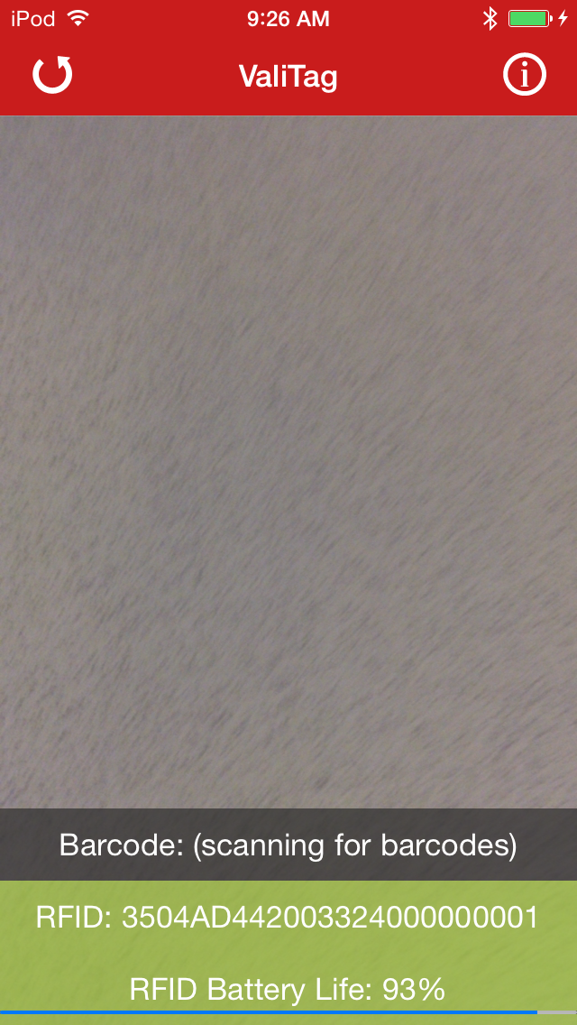If an RFID tag was already read, it will be displayed:

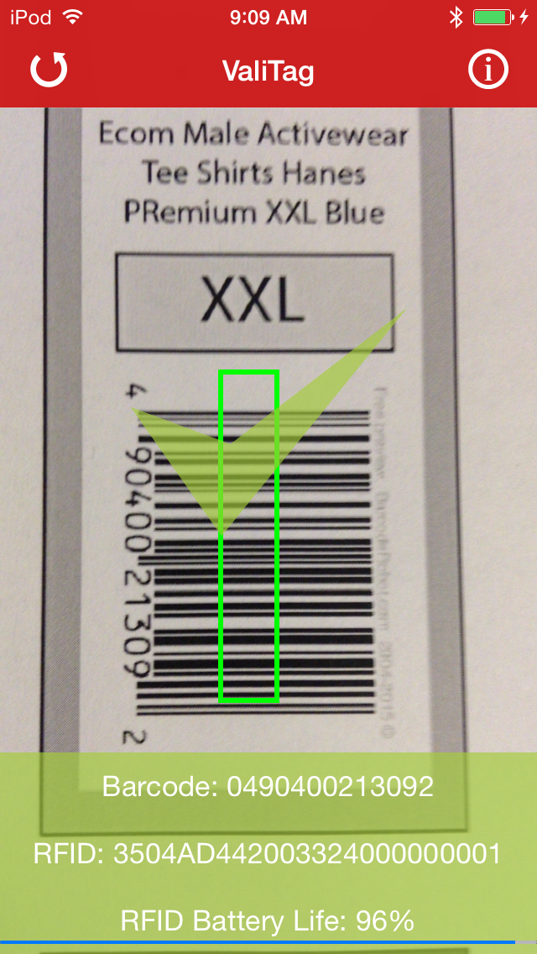Position the barcode for the camera to read it. Once read, you will see a green rectangle on the barcode image and the number will be displayed.

If it is a match – meaning the EPC tag is properly encoded to match the barcode - you will see a green check mark, and the tag fields will also be green.

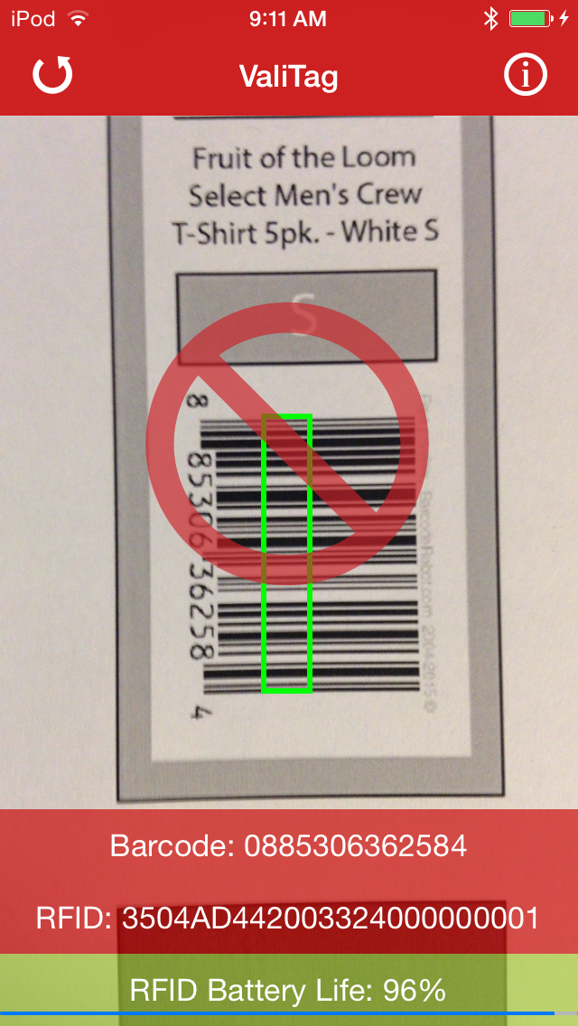If it is NOT a match – meaning the EPC tag is not properly encoded to match the barcode – you will see a red circle, and the tag fields will also be read:



To read another tag, or try again, press the reset button on the upper left:



To see more details on the two tags, click on the info button on the upper right:

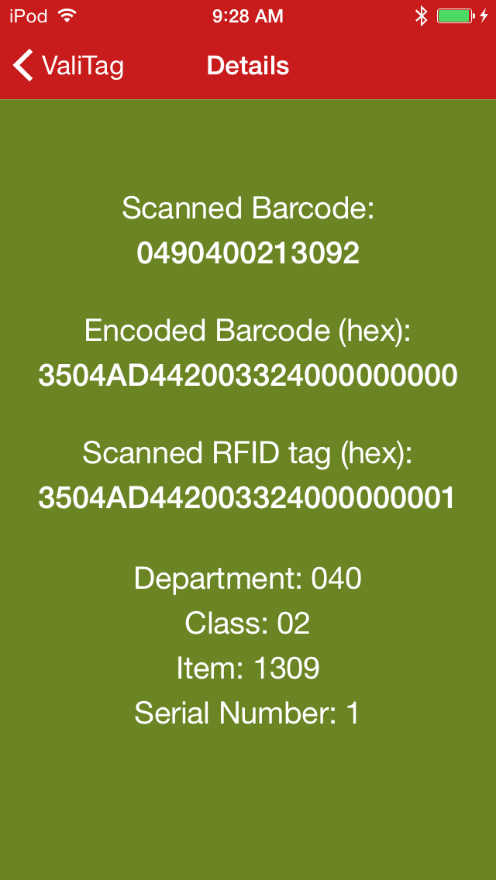

Select ValiTag on the upper left to return to the main scanning page:

On the main scanning page, you can rotate the device horizontally and see more information in landscape mode:

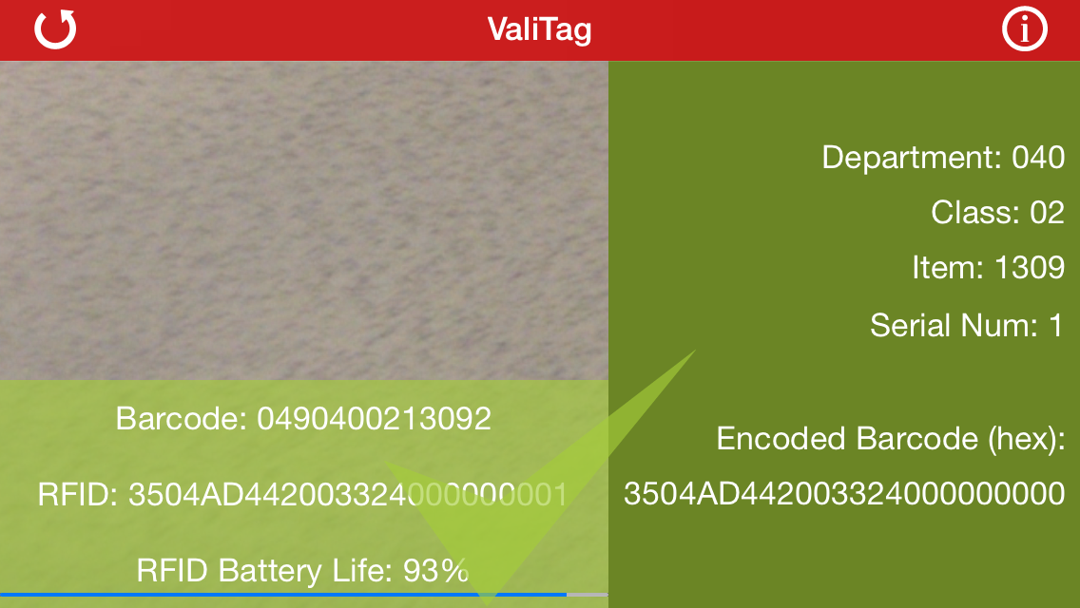

Landscape mode works will with an iPad propped open on a table facing the reader. You can position the tag to be tested between the two, and not have to touch either device.

Important note: the power settings on the RFID reader have been turned down enough so that only tags within the immediate range of the reader will be read. You should be able to keep tags at arm’s reach away on either side and they won’t be read, but occasionally they are. You may need to test this in your environment until you are sure you are reading only the RFID tag whose barcode is also being read. To keep the application simple, these settings are not configurable.

When the battery of the reader gets too low, charge it (or in the case of the Zebra reader, replace the battery).

## Basic Troubleshooting

* **No Battery life displayed**
  + This can be an indication that the reader is not properly connected, but not all readers report their battery life in the same manner, so it is not a guarantee.
  + Check the reader connections (headphone plug or Bluetooth)
* **Connecting to reader message**
  + If this message is displayed, press the reset button in the upper left and try again.
  + This is more often an issue with a Bluetooth reader.
  + If after a couple of resets it still won’t connect
    - If you are using an attached reader, check the plug connection and restart
    - If you are using a Bluetooth reader, proceed to the next step
* **Bluetooth connection fails**
  + Exit ValiTag
  + Go into iOS Settings, Bluetooth and click on the ‘i’ button to the right of the RFID reader
  + Select “Forget this Device” and accept

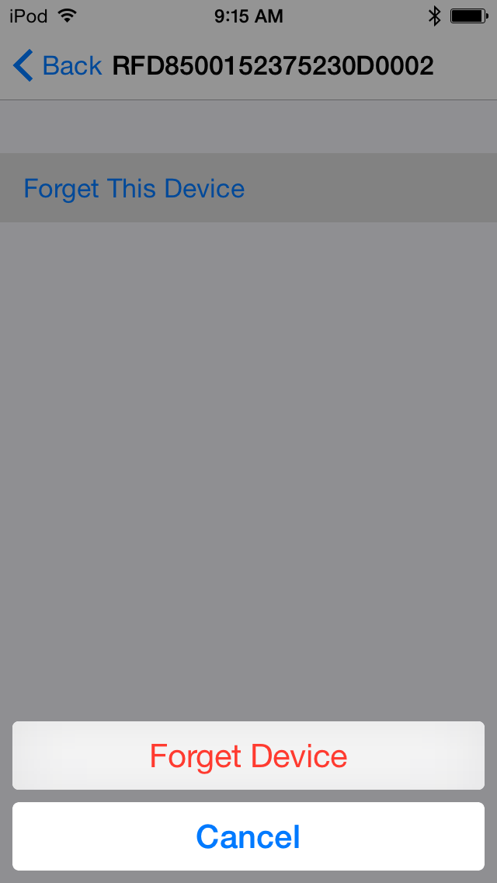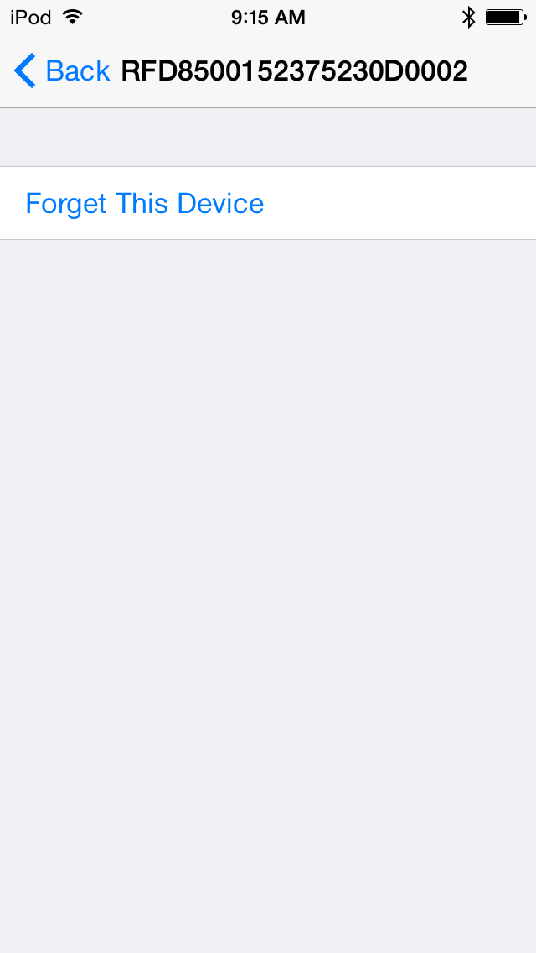

* + Once forgotten, go through the setup steps outlined in “Bluetooth Setup” to reconnect the reader.
  + Wait until it is connected and then relaunch ValiTag.
  + The reader should connect automatically.